**FPT ACADEMY INTERNATIONAL**



**FPT – APTECH COMPUTER EDUCATION**

**PHTV.net**

|  |  |  |  |  |  |  |  |  |
| --- | --- | --- | --- | --- | --- | --- | --- | --- |
|  | **Center Name** | | | |  | ACE-HCMC-2-FPT |  |  |
|  |  |  |  |  |  | Address: 590 Cach Mang Thang Tam, District 3, HCMC, | |  |
|  |  |  |  |  |  | VietNam. |  |  |
|  | **Instructor** | | |  |  | Mrs. Le Mong Thuy |  |  |
|  | **Class** | | |  |  | T1.2209.E0 |  |  |
|  | **Group** | | |  |  | 2 |  |  |
|  |  |  |  |  |  | **Name** | **Student ID** |  |
|  |  |  |  |  |  | Pham Huy Hoang | Student1421362 |  |
|  | **Group members** | | | |  | Tran Gia Toan | Student1416122 |  |
|  |  |  |  |  |  | Le Pham Tran Phu | Student1414240 |  |
|  |  |  |  |  |  | Bui Quoc Viet | Student1420715 |  |
|  | **Duration** |  |  | **Start date** |  | July 1st 2023 |  |  |
|  |  |  | **End date** |  | August 2nd 2023 |  |  |
|  |  |  |  |  |  |  |

CONTENT

REVIEW 1 2

ACKNOWLEDGE 2

INTRODUCTION 3

PROBLEM DEFINITION 3

REQUIREMENT SPECIFICATION 3

TASK SHEET REVIEW 1 7

REVIEW 2 8

USE CASE 8

TASK SHEET REVIEW 2 30

# REVIEW 1

## ACKNOWLEDGE

Our group would like to devote this chapter to express our sincere appreciation to all those who offered us valuable assistance during in carrying out this Project.

Firstly, we owe a debt of gratitude to our dedicated instructor, Mrs. Le Mong Thuy, whose suggestions and encouragement helped us to overcome not only technological challenges but also psychological tension. Without her, our work could not complete successfully.

Secondly, it would have been impossible to carry out and complete this project without the collaboration among our team members. Although we have gone through many obstacles during the project implementation, eventually we gained what we aimed at by our hard work, our strong commitment and of course, our brotherhood.

Finally, thanks to Aptech’s eProject assignment, we had a golden opportunity to apply what we have learnt into reality and gain hands-on experience which is essential for our future career.

## INTRODUCTION

Welcome to our online movie ticket booking website! If you're a film enthusiast looking to experience the latest hot releases right from the comfort of your home, then you've come to the right place. Our website provides a convenient and reliable platform for you to search for and book movie tickets, ranging from the latest blockbusters to timeless classics that have captivated audiences.

With the advancement of technology, you no longer have to wait in queues at the theater or worry about seats running out. With just a few clicks, you can access a diverse selection of films and choose the ones that resonate with your taste. We not only bring you the hottest movies but also deliver a high-quality and convenient movie-watching experience.

Our website is designed to be simple and user-friendly. You can easily search for movies by genre, actors, directors, or titles. Additionally, we provide detailed information about each film, including trailers, ratings, and popular user reviews.

Visit our website now to explore a world of cinematic wonders and book your movie tickets with ease. Get ready to immerse yourself in captivating stories, stunning visuals, and unforgettable moments, all from the convenience of your own home. Enjoy the magic of movies like never before!

## PROBLEM DEFINITION

1. **User-Friendly and Easy-to-Use Interface**

PHTV features an intuitive and user-friendly interface, allowing users to effortlessly find information about currently showing movies, showtimes, theaters, and seating arrangements. The website organizes information in a clear and logical manner, making it easy for users to understand and locate the desired information.

1. **Flexible Movie Search and Showtime Options**

PHTV provides an intelligent search tool that allows users to search for movies based on criteria such as movie title, actors, directors, and genres. Additionally, the website offers detailed showtime schedules for various theaters, enabling users to easily select suitable showtimes according to their personal schedules.

1. **Easy Seat Selection and Booking Process**

With PHTV, seat selection and ticket booking become simple and convenient. The website provides detailed seating maps for each theater, allowing users to choose their preferred seats based on visual seating arrangements. After selecting seats, users can proceed with secure and fast online payment.

1. **Theater Information and Movie Ratings**

PHTV provides comprehensive information about theaters, including addresses, working hours, and theater types. Users can also access movie ratings and reviews, assisting them in making informed decisions about movie choices.

## REQUIREMENT SPECIFICATION

**CUSTOMER'S REQUIREMENT SPECIFICATIONS**

* + The site provides information about movies and cinemas. Users can look up showtimes, ticket prices, book tickets online, and receive notifications about new movies. Additionally, the website also offers movie reviews, news, and industry events related to the film industry.

1. **Functional Requirement Specifications**

**1.1. Function of User:** User can:

* + REQ-01. Register.
  + REQ-02. Login, logout.
  + REQ-03. Movie Search
  + REQ-04. Showtime Viewing
  + REQ-05. Selecting Showtime and Seats
  + REQ-06. Ticket Booking
  + REQ-07. Viewing Theater Information
  + REQ-08. News and Offers
  + REQ-09. Interaction and Feedback

**1.2. Function of Admin:** Admin can:

* REQ-09. Login, logout.
* REQ-10. Change password
* REQ-11. Movie Management
* REQ-12. Showtime Management
* REQ-13. Theater Management
* REQ-14. Seat Mapping
* REQ-15. User Management
* REQ-16. Content Management

**Note:** Constraint validation must be provided wherever necessary. And the website should have the smooth navigations.

**2. System Requirement Specifications**

**2.1.** **Server requirements:**

* Hardware:

|  |  |  |  |  |
| --- | --- | --- | --- | --- |
|  | **Component** | **Requirement** |  |  |
|  |  |  |  |  |
|  | **CPU** | Processor type: |  |  |
|  |  | Pentium IV-compatible processor or faster |  |  |
|  |  | Processor speed: |  |  |
|  |  | Recommended: 2.0 GHz or faster |  |  |
|  |  |  |  |  |
|  | **OS** | Microsoft Windows 10 or higher with IIS |  |  |
|  |  |  |  |  |
|  | **Memory (RAM)** | RAM: |  |  |
|  |  | Minimum: 512 MB |  |  |
|  |  | Recommended: 2 GB or more |  |  |
|  |  |  |  |  |
|  |  |  |  |  |
|  | **Hard Drive** | Free space: |  |  |
|  |  | Minimum: 200 MB |  |  |
|  |  | Recommended: 50 GB or more |  |  |
|  |  | Maximum: Operating system maximum |  |  |
|  |  |  |  |  |
|  |  |  |  |  |
|  | | |  |  |

* Software:

**Component**

**Browser**

**Requirement**

Microsoft Windows 10 and newer

* Google Chrome (latest stable version)
* Firefox (latest stable version)
* Microsoft Edge (latest stable version; Chromium-based only)

MacOS 10.12 and newer

* Google Chrome (latest stable version)
* Safari (latest stable version)

For best results, use the latest version of Google Chrome.

**2.2. Client requirements:**

* Hardware:

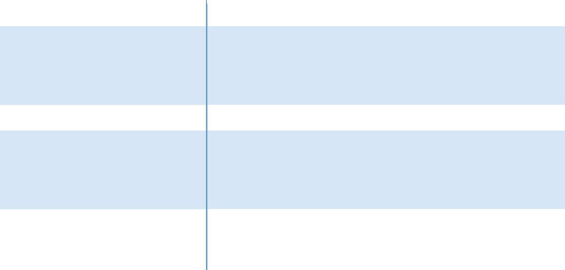

**Component**

**CPU**

**OS**

**Memory (RAM)**

**Hard Drive**

**Requirement**

Processor type:

Pentium III-compatible processor or faster

Processor speed:

Recommended: 1.0 GHz or faster

All OS(Window ,Linux ,Android ,Mac OS …)

RAM:

Minimum: 512 MB

Recommended: 1 GB or more

Maximum: Operating system maximum

Free space:

Minimum: 10 MB



* Software:

**Component**

**Web Browser**

**Requirement**

Microsoft Windows 10 and newer

* Google Chrome (latest stable version)
* Firefox (latest stable version)
* Microsoft Edge (latest stable version; Chromium-based only)

MacOS 10.12 and newer

* Google Chrome (latest stable version)
* Safari (latest stable version)

For best results, use the latest version of Google Chrome.

1. **Development Software:**
   * Microsoft Windows
   * Microsoft Visual Studio
   * Xampp
   * Google Chrome
2. **Technology:**
   * PHP - Laravel
   * Javascript, ReactJS, Lodash, jQuery, Redux Thunk
   * HTML/CSS, Bootstrap, Tailwindcss, Antdesign

|  |  |  |  |  |  |  |  |  |  |  |
| --- | --- | --- | --- | --- | --- | --- | --- | --- | --- | --- |
| **Project Ref. No.:** | |  | **Activity** | **Date of Preparation of Activity Plan:** | | | | | |  |
|  |  |  |  |  |  |  |  |  |  |
|  |  | **Project** | **Plan** |  |  |  |  |  |  |  |
|  |  | **Title:** | **Prepared** |  |  |  |  |  |  |  |
|  |  |  | **By:** |  |  |  |  |  |  |  |
| **Sr.** |  |  |  | **Actual** | **Actual** |  | **Team** |  |  |
|  |  |  |  |  |  |  |
| **Task** |  |  |  | **Start** |  | **Mate** | **Status** |  |
| **No.** |  |  |  | **Days** |  |  |
|  |  |  |  | **Date** |  | **Names** |  |  |
|  |  |  |  |  |  |  |  |  |
|  |  |  |  |  |  |  |  |  |  |  |
| 1 | Acknowledgement |  |  | 18/6/2023 | | 1 |  | All | Completed |  |
|  |  |  |  |  |  |  |  | member |  |  |
|  |  |  |  |  |  |  |  |  |  |  |
| 2 | Introduction | PHTV | Pham  Huy Hoang | 18/6/2023 | | 1 |  | All | Completed |  |
|  |  |  |  |  |  | member |  |  |
|  |  |  |  |  |  |  |  |  |  |  |
| 3 | Problem Definition | 18/6/2023 | | 1 |  | All  member | Completed |  |
|  |  |
|  |  |
| 4 | Requirement | 18/6/2023 | | 1 |  | All | Completed |  |
|  |  |  |  |
|  | Specification |  |  |  |  |  |  | member |  |  |
|  |  |  |  |  |  |  |  |  |  |  |
| 5 | Task sheet review |  |  | 18/6/2023 | | 1 |  | Hoang | Completed |  |
|  |  |  |  |  |  |  |  |  |  |  |
| **Date: 19/6/2023** | | |  |  |  |  |  |  |  |  |
|  | | |  |  |  | | | |  |  |
| Signature of Instructor: | | |  |  | Signature of Team Leader: | | | |  |  |
| **Mrs. Le Mong Thuy** | | |  |  | **Pham Huy Hoang** | | |  |  |  |
|  |  |  |  |  |  |  |  |  |  |  |

## TASK SHEET REVIEW 1

# REVIEW 2

## USE CASE

1. **VISITOR**

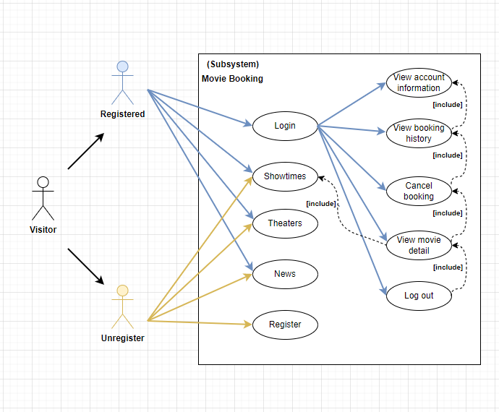

* 1. **LOGIN AS VISITOR:**

|  |  |  |
| --- | --- | --- |
| **Use Case Name** | Login | |
| **Actors** | Registered Customer | |
| **Description** | Customer who has registered an account can login | |
| **Requirements** | Customer provides username and password | |
| **Pre-conditions** | Visitor must register an account | |
| **Post-conditions** | Success: Visitor is logged in to website | |
| Fail: Refill information | |
|  | **Actor’s actions:** | **System’s responses:** |
|  | 1. Visitor clicks ‘Login’ button on Home  Page. | 2. System redirects to Login Page with the following controls: |
|  |  | - “Username” text field |
| **Basic flow** |  | - “Password” text field |
|  |  | - “Login” button |
|  | 3. Actor inputs Username and Password,  then click the ‘Login’ button. | 4. System checks the information. |
|  |  | 5. System redirects to Customer’s  homepage. |
| **Exceptions** | **Actor’s actions:** | **System’s responses:** |
| 1. Actor inputs invalid username and password. | System redirects to Login page with the following controls:  - “User” text field |

|  |  |  |
| --- | --- | --- |
|  |  | * “Password” text field * “Login” button   System shows message: “Invalid username and password”. |

* 1. **REGISTER AS VISITOR:**

|  |  |  |
| --- | --- | --- |
| **Use Case Name** | Register as Visitor | |
| **Actors** | New Customer | |
| **Description** | Customer who has not registered an account | |
| **Requirements** | Customer registers an account on the website and becomes a member | |
| **Pre-conditions** | Customer provides their register information | |
| **Post-conditions** | Success: Visitor creates a User account in this website | |
| Fail: Refill information | |
| **Basic flow** | **Actor’s actions:** | **System’s responses:** |
| 1. Visitor clicks “Register” button on  Home Page. | 2. System redirects to Register page and displays Registration form with the following controls:   * “Username” text field * “Password” text field * “Email” text field * “Phone” text field |

|  |  |  |
| --- | --- | --- |
|  | 3. Visitor inputs register’s information and click “Register” button. | * “Name” text field * “Register” button  1. System validates the information. 2. System inserts the account into database 3. System show success message. |
| **Exceptions** | **Actor’s actions:** | **System’s responses:** |
| * Actor left “Username” text field blank. * Username has already existed. * Actor left “Password” text field blank. * Actor left “Confirm Password” text   field blank.   * Password and confirm password   don’t match.   * Actor left “Email” text field blank. * Email has already existed. * Actor left “Phone” text field blank. * Input phone is not numeric format or phone length is not between 8 and 14 characters. * Actor left “Email” text field blank or   input an invalid email address. | System displays message to customer:   * “Username cannot be blank”. * “This Username has already existed”. * “Password cannot be blank”. * “Confirm Password cannot be blank”. * “Confirm Password does not match password.”. * “Email cannot be blank”. * “This Email has already existed”. * “Phone cannot be blank”. * “The phone number should be numeric only and must be between 8 and 14 digits”. * “Email is invalid”. |

* 1. **SHOWTIMES:**

|  |  |  |
| --- | --- | --- |
| **Use case name** | Showtimes | |
| **Actors** | Registered Customer/ New Customer | |
| **Description** | Customer can view showtimes and movie detail | |
| **Requirements** | Customer select showtimes and then select movie to show movie’s detail | |
| **Pre-conditions** | N/A | |
| **Post-conditions** | N/A | |
| **Basic flow** | **Actor’s actions:** | **System’s responses:** |
| 1. Actor select showtimes | 2. System shows list of movies |

* 1. **BUY TICKET:**

|  |  |  |
| --- | --- | --- |
| **Use case name** | Buy ticket | |
| **Actors** | Registered customer | |
| **Description** | Customer can order their ticket for the movie | |
| **Requirements** | Customer select movie, seats to buy | |
| **Pre-conditions** | Customer must log in to website and only can buy ticket for the seats which are available. | |
| **Post-conditions** | Success: Buy ticket successfully. | |
| Fail: Ticket is canceled. | |
| **Basic flow** | **Actor’s actions:** | **System’s responses:** |
|  | 1. Actor chooses “Buy ticket” to select movie they want. | 2. System redirects to showtime page. |
|  | 3. Actor chooses “seats” on the seating plan. | 4. System redirects displays a list of selected seat and total price. |
|  | 5. Actor selects click “Payment” to confirm buying ticket | 6. System validates inputs by movie’s name of ticket |
|  |  | 7. System change status seating plan in database. |
|  |  | 8. System displays message : successful or error. |

* 1. **VIEW ACCOUNT INFORMATION:**

|  |  |  |
| --- | --- | --- |
| **Use case name** | View account information | |
| **Actors** | Registered Customer | |
| **Description** | Customer can view account information | |
| **Requirements** | Customer login to this website | |
| **Pre-conditions** | Customer provides their register information | |
| **Post-conditions** | Success: Visitor creates a User account in this website | |
| Fail: Refill information | |
| **Basic flow** | **Actor’s actions:** | **System’s responses:** |
| 1. Actor select personal information | 2. System shows details of personal information |

* 1. **VIEW BOOKING HISTORY:**

|  |  |  |
| --- | --- | --- |
| **Use case name** | View booking history | |
| **Actors** | Registered Customer | |
| **Description** | Customer can view booking detail | |
| **Requirements** | Customer select booking history to show booking’s detail | |
| **Pre-conditions** | Customer provides their register information | |
| **Post-conditions** | Success: Visitor creates a User account in this website | |
| Fail: Refill information | |
| **Basic flow** | **Actor’s actions:** | **System’s responses:** |
| 1. Actor select booking history | 2. System shows detail of booking history |

* 1. **VIEW MOVIE DETAIL:**

|  |  |  |
| --- | --- | --- |
| **Use case name** | View movie detail | |
| **Actors** | Registered customer | |
| **Description** | Customer can view movie detail | |
| **Requirements** | Customer select movie to show detail | |
| **Pre-conditions** | Customer must login if they want to comment on movie. | |
| **Post-conditions** | Success: Visitor creates a User account in this website | |
| Fail: Refill information | |
| **Basic flow** | **Actor’s actions:** | **System’s responses:** |
| 1. Actor select movie detail | 2. System shows information of movie |

* 1. **LOG OUT:**

|  |  |  |
| --- | --- | --- |
| **Use case name** | Log out | |
| **Actors** | Registered customer | |
| **Description** | Customer back to home page as new customer | |
| **Requirements** | Customer must has at least 1 account | |
| **Pre-conditions** | Customer must log in before log out | |
| **Post-conditions** | Success: Actor log out successfully | |
| N/A | |
| **Basic flow** | **Actor’s actions:** | **System’s responses:** |
|  | 1. Actor click “Log out” button | 1. System displays message : log out successful. 2. System redirect customer to homepage. |
|  | | |

* 1. **THEATERS:**

|  |  |  |
| --- | --- | --- |
| **Use case name** | View theaters detail | |
| **Actors** | Registered Customer/ New Customer | |
| **Description** | Customer can view theaters detail | |
| **Requirements** | Customer select theaters to show each theater in detail | |
| **Pre-conditions** | N/A | |
| **Post-conditions** | N/A | |
| **Basic flow** | **Actor’s actions:** | **System’s responses:** |
|  | 1. Actor select theaters | 2. System shows list and details of theaters |

* 1. **NEWS**

|  |  |  |
| --- | --- | --- |
| **Use case name** | View news, review related to cinema | |
| **Actors** | Registered Customer/ New Customer | |
| **Description** | Customer can view news, review related to cinema | |
| **Requirements** | Customer select news button to show news, review related to cinema | |
| **Pre-conditions** | N/A | |
| **Post-conditions** | N/A | |
| **Basic flow** | **Actor’s actions:** | **System’s responses:** |
|  | 1. Actor select news | 2. System shows news, review related to cinema |

1. **ADMIN**

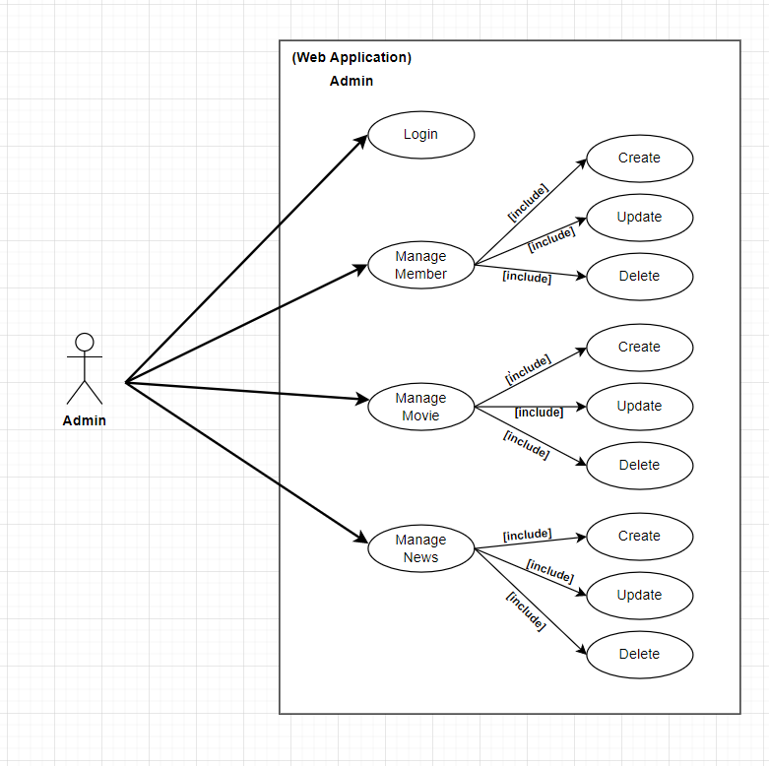

* 1. **LOGIN**

|  |  |  |
| --- | --- | --- |
| **Use case name** | Login | |
| **Actor** | Admin | |
| **Description** | When admin wants to manage member , news and movie | |
| **Requirements** | Admin provides username and password | |
| **Pre-conditions** | Admin must be exist on database | |
| **Post-conditions** | Success: Admin is logged in to website admin | |
| Fail: refill information | |
| **Basic flow** | **Actor’s actions:** | **System’s responses:** |
| 1. Actor clicks on ‘Login’ button.  3. Actor inputs Username and Password, then click the ‘Login’ button. | 2. System redirects to Login Page with the following controls:   * 'Username' text field * 'Password' text field * 'Login' button  1. System validates the information. 2. System redirects to Admin website |
| **Exceptions** | **Actor’s actions:** | **System’s responses:** |
| 1. Actor inputs invalid email and password | System redirects to Login page with the following controls:   * ‘Username’ text field * ‘Password’ text field * ‘Login’ button. |

* 1. **MANAGE MEMBER**
     1. **Update member**

|  |  |  |
| --- | --- | --- |
| **Use case name** | Update member’s detail | |
| **Actor** | Admin | |
| **Description** | When admin wants to update member | |
| **Requirements** | Admin provides product’s information | |
| **Pre-conditions** | Actor is logged in admin | |
| **Post-conditions** | Success: member detail is updated in the database | |
| Fail: refill information | |
|  | **Actor’s actions:** | **System’s responses:** |
| 1. Actor chooses Member Tab on menu. | 2. System redirects to ‘Member Details’  page and display a list of existing |

|  |  |  |
| --- | --- | --- |
| **Basic flow** | 3. Actor clicks on ‘View Details’ on a  member.  5. Actor chooses the criteria they want to update and input information. | product.  4. System displays a form with the following fields.   * username * name * email * phone number * image  1. System validates inputs. 2. System update information member into database. 3. System displays confirmation message or error message. 4. System redirects to member’s detail   page. |

* + 1. **Delete member**

|  |  |  |
| --- | --- | --- |
| **Use case name** | Delete member | |
| **Actor** | Admin | |
| **Description** | When admin wants to delete member from the database | |
| **Requirements** | Admin provides product’s information | |
| **Pre-conditions** | Actor is logged in admin | |
| **Post-conditions** | Success: product is delete in the database | |
| Fail: product is not delete from the database | |
|  | **Actor’s actions:** | **System’s responses:** |
|  | 1. Actor chooses Member Tab on menu.  3. Actor clicks ‘Delete’ button. | 2. System redirects to ‘Member List’ page and display a list of existing member. |
|  |  | 4. System delete member in the database |
| **Basic flow** |  | 5. System displays confirmation or error. |

* 1. **MANAGE MOVIE**
     1. **Create new movie**

|  |  |  |
| --- | --- | --- |
| **Use case name** | Create new movie | |
| **Actor** | Admin | |
| **Description** | When admin wants to create a new movie | |
| **Requirements** | Actor provides product’s information | |
| **Pre-conditions** | Actor is logged in admin | |
| **Post-conditions** | Success: new product is added into the database | |
| Fail: refill information | |
|  | **Actor’s actions:** | **System’s responses:** |
|  |  | 2. System redirects to ‘Movie’ page  and display a list of existing Movie. |
|  | 1. Actor chooses Movie Tab on menu. |  |
|  | 3. Actor clicks ‘Add New Movie  button. | 4. System displays a form with the  following fields: |
|  |  | - id |
| **Basic flow** | 5. Actor inputs information to create  new product | - category_id |
|  |  | - name |
|  |  | - description |
|  |  | - time |

|  |  |  |
| --- | --- | --- |
|  |  | * detail * image  1. System validates inputs. 2. System adds movie into database. 3. System displays confirmation message or error message. |

* + 1. **Update movie**

|  |  |  |
| --- | --- | --- |
| **Use case name** | Update movie’s detail | |
| **Actor** | Admin | |
| **Description** | When admin wants to update movie | |
| **Requirements** | Admin provides product’s information | |
| **Pre-conditions** | Actor is logged in admin | |
| **Post-conditions** | Success: movie is updated in the database | |
| Fail: refill information | |
|  | **Actor’s actions:** | **System’s responses:** |
| 1. Actor chooses Movie Tab on menu. | 2. System redirects to ‘Movie Details’  page and display a list of existing |

|  |  |  |
| --- | --- | --- |
| **Basic flow** | 3. Actor clicks on ‘View Details’ on a  movie.  5. Actor chooses the criteria they want to update and input information. | product.  4. System displays a form with the following fields.   * id * category_id * name * description * time * detail * image  1. System validates inputs. 2. System update information member into database. 3. System displays confirmation message or error message. 4. System redirects to movie’s detail page. |

* + 1. **Delete movie**

|  |  |  |
| --- | --- | --- |
| **Use case name** | Delete movie | |
| **Actor** | Admin | |
| **Description** | When admin wants to delete movie from the database | |
| **Requirements** | Admin provides product’s information | |
| **Pre-conditions** | Actor is logged in admin | |
| **Post-conditions** | Success: movie is delete in the database | |
| Fail: movie is not delete from the database | |
|  | **Actor’s actions:** | **System’s responses:** |
|  | 1. Actor chooses Movie Tab on menu.  3. Actor clicks ‘Delete’ button. | 2. System redirects to ‘Movie List’ page and display a list of existing movie. |
|  |  | 4. System delete movie in the database |
| **Basic flow** |  | 5. System displays confirmation or error. |

* 1. **MANAGE NEWS**
     1. **Create new News**

|  |  |  |
| --- | --- | --- |
| **Use case name** | Create new News | |
| **Actor** | Admin | |
| **Description** | When admin wants to create a new News, review | |
| **Requirements** | Actor provides product’s information | |
| **Pre-conditions** | Actor is logged in admin | |
| **Post-conditions** | Success: new article is added into the database | |
| Fail: refill information | |
|  | **Actor’s actions:** | **System’s responses:** |
|  |  | 2. System redirects to ‘News’ page  and display a list of existing News, review. |
|  | 1. Actor chooses News Tab on menu. |  |
|  | 3. Actor clicks ‘Add New Article  button. | 4. System displays a form with the  following fields: |
|  |  | - id |
| **Basic flow** | 5. Actor inputs information to create  new article | - category_id |
|  |  | * title |
|  |  | - description |
|  |  | - time |

|  |  |  |
| --- | --- | --- |
|  |  | * detail * image * poster  1. System validates inputs. 2. System adds Article or review into database. 3. System displays confirmation message or error message. |

* + 1. **Update News**

|  |  |  |
| --- | --- | --- |
| **Use case name** | Update News’s detail | |
| **Actor** | Admin | |
| **Description** | When admin wants to update Article, review | |
| **Requirements** | Admin provides article’s information | |
| **Pre-conditions** | Actor is logged in admin | |
| **Post-conditions** | Success: Article is updated in the database | |
| Fail: refill information | |
|  | **Actor’s actions:** | **System’s responses:** |
| 1. Actor chooses News Tab on menu. | 2. System redirects to ‘News Details’  page and display a list of existing |

|  |  |  |
| --- | --- | --- |
| **Basic flow** | 3. Actor clicks on ‘View Details’ on a  article.  5. Actor chooses the criteria they want to update and input information. | News, review.  4. System displays a form with the following fields.   * id * category_id * title * description * time * detail * image * poster  1. System validates inputs. 2. System update information News or review into database. 3. System displays confirmation message or error message. 4. System redirects to News’s detail page. |

* + 1. **Delete News**

|  |  |  |
| --- | --- | --- |
| **Use case name** | Delete News | |
| **Actor** | Admin | |
| **Description** | When admin wants to delete News from the database | |
| **Requirements** | Admin provides product’s information | |
| **Pre-conditions** | Actor is logged in admin | |
| **Post-conditions** | Success: Article is delete in the database | |
| Fail: product is not delete from the database | |
|  | **Actor’s actions:** | **System’s responses:** |
|  | 1. Actor chooses News Tab on menu.  3. Actor clicks ‘Delete’ button. | 2. System redirects to ‘Articles List’ page and display a list of existing Article or review. |
|  |  | 4. System delete article in the database |
| **Basic flow** |  | 5. System displays confirmation or error. |

## TASK SHEET REVIEW 2

|  |  |  |  |  |  |  |  |  |  |  |
| --- | --- | --- | --- | --- | --- | --- | --- | --- | --- | --- |
| **Project Ref. No.:** | |  | **Activity** | **Date of Preparation of Activity Plan:** | | | | | |  |
|  |  |  |  |  |  |  |  |  |  |
|  |  | **Project** | **Plan** |  |  |  |  |  |  |  |
|  |  | **Title:** | **Prepared** |  |  |  |  |  |  |  |
|  |  |  | **By:** |  |  |  |  |  |  |  |
| **Sr.** |  |  |  | **Actual** | **Actual** |  | **Team** |  |  |
|  |  |  |  |  |  |  |
| **Task** |  |  |  | **Start** |  | **Mate** | **Status** |  |
| **No.** |  |  |  | **Days** |  |  |
|  |  |  |  | **Date** |  | **Names** |  |  |
|  |  |  |  |  |  |  |  |  |
|  |  |  |  |  |  |  |  |  |  |  |
| 1 | Visitor  LOGIN AS VISITOR  REGISTER AS VISITOR  SHOWTIMES  BUY TICKET  VIEW ACCOUNT INFORMATION  VIEW BOOKING HISTORY  VIEW MOVIE DETAIL  LOG OUT  THEATERS  NEWS | PHTV | Pham  Huy Hoang | 5/7/2023 | | 1 |  | All | Completed |  |
|  |  |  |  |  |  |  |  | member |  |  |
|  |  |  |  |  |  |  |  |  |  |  |
| 2 | ADMIN  LOGIN  MANAGE MEMBER  DELETE MEMBER  MANAGE MOVIE  MANAGE NEWS |  |  | 5/7/2023 | | 1 |  | All | Completed |  |
|  |  |  |  |  |  | member |  |  |
|  |  |  |  |  |  |  |  |  |  |  |
| 3 | Task sheet review |  |  | 5/7/2023 | | 1 |  | Hoang | Completed |  |
|  |  |  |  |  |  |  |  |  |  |  |
| **Date: 5/7/2023** | | |  |  |  |  |  |  |  |  |
|  | | |  |  |  | | | |  |  |
| Signature of Instructor: | | |  |  | Signature of Team Leader: | | | |  |  |
| **Mrs. Le Mong Thuy** | | |  |  | **Pham Huy Hoang** | | |  |  |  |
|  |  |  |  |  |  |  |  |  |  |  |

# REVIEW 3

## SITE MAP

**HOME SITE MAP**

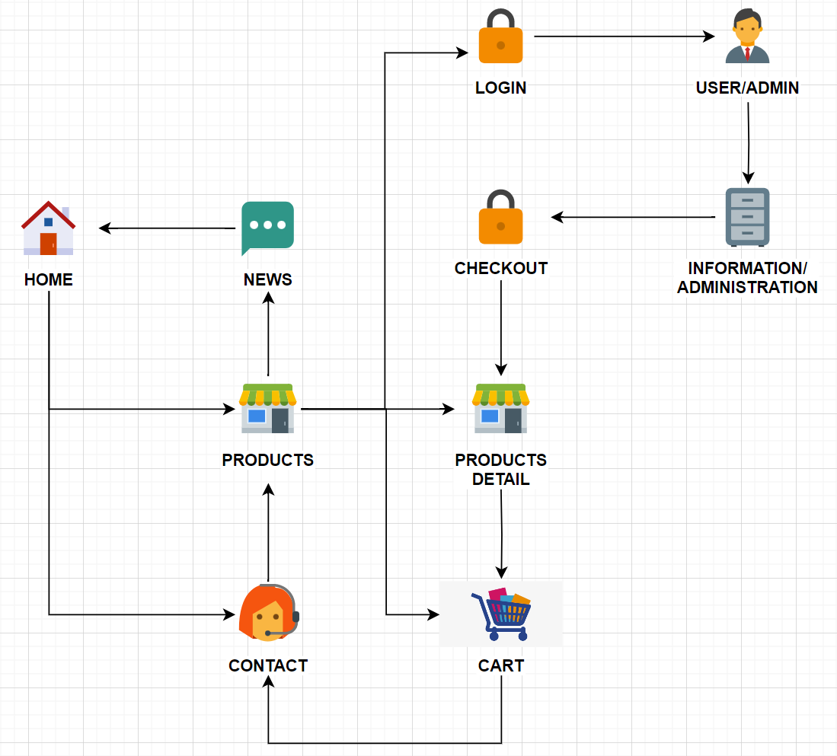

**ADMIN’S SITE MAP**

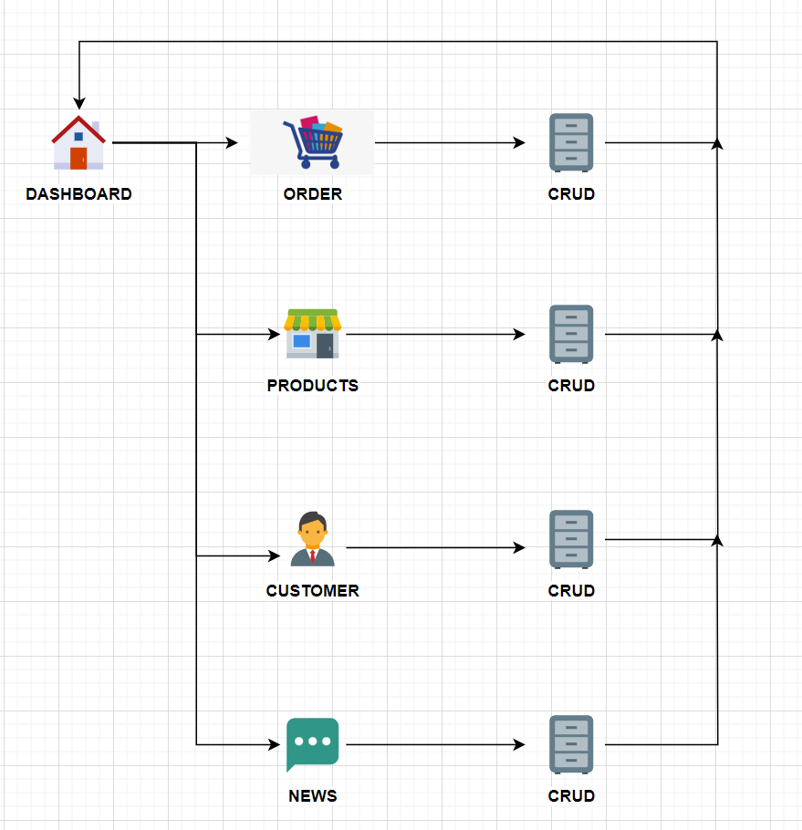

## PHTV WEBSITE WIREFRAME

**HOMEPAGE**

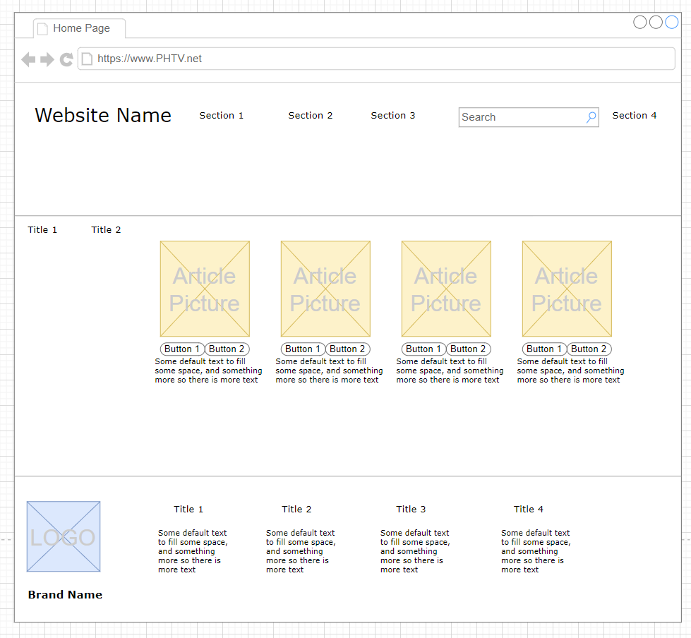

**ADMIN**

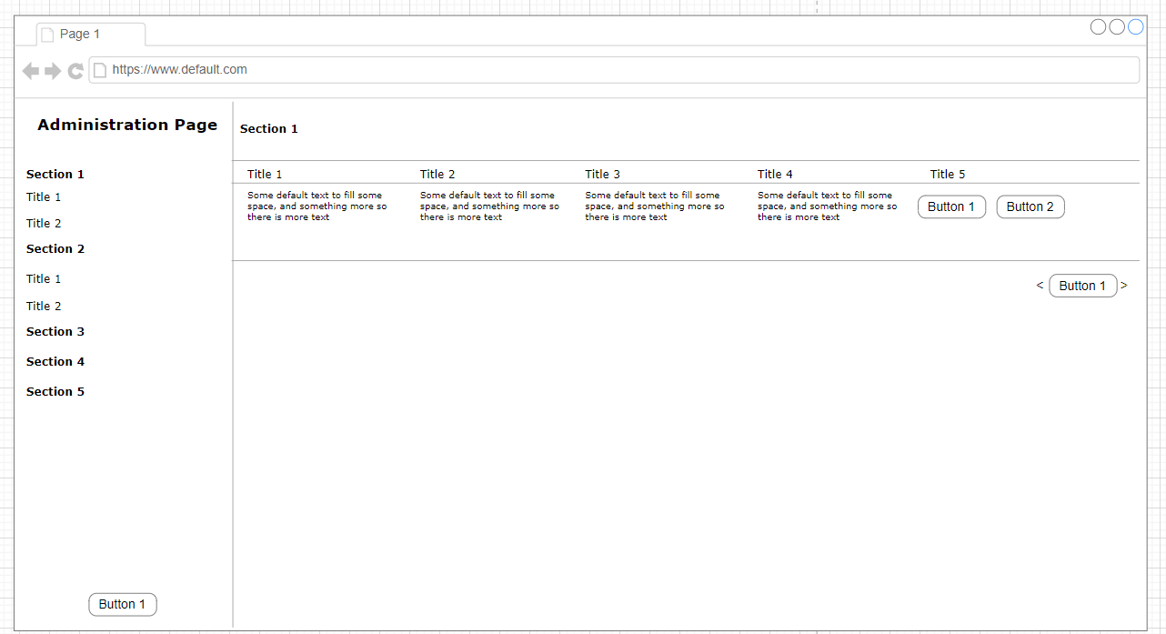

**USER**

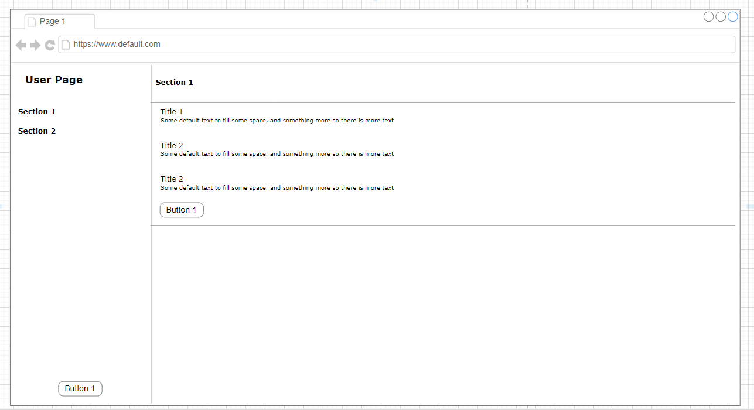

**PRODUCT**

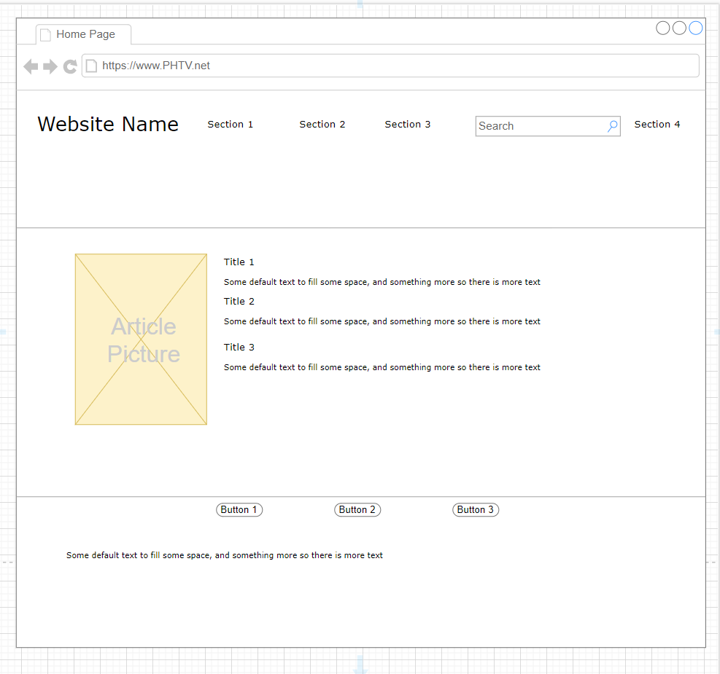

**NEWS**

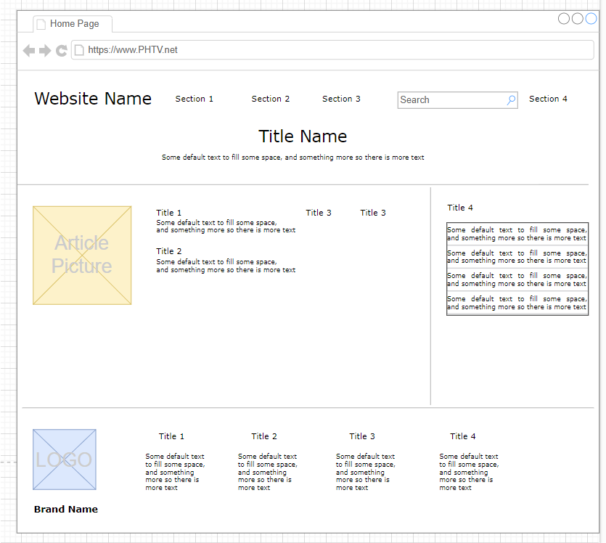

**CONTACT**

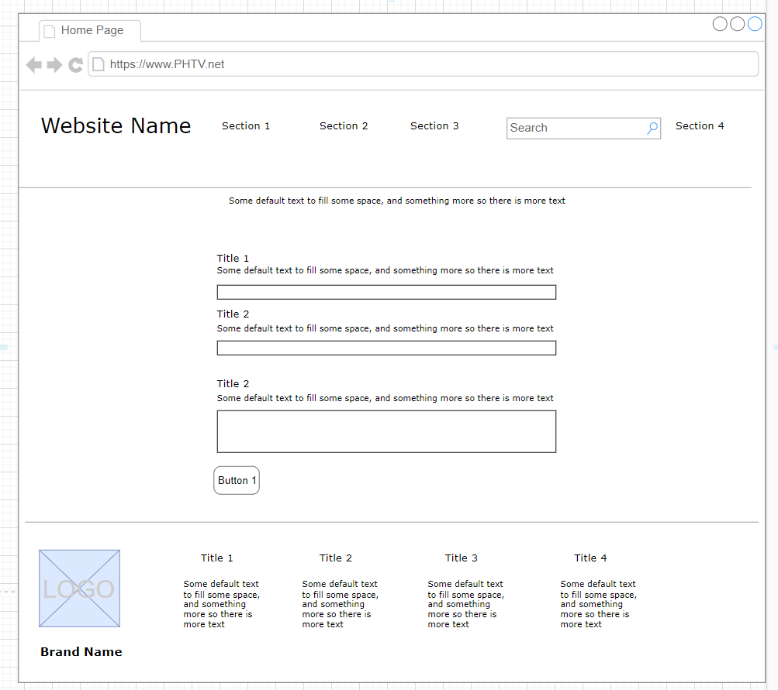

## PHTV WEBSITE SCREENSHOT

**HOMEPAGE**

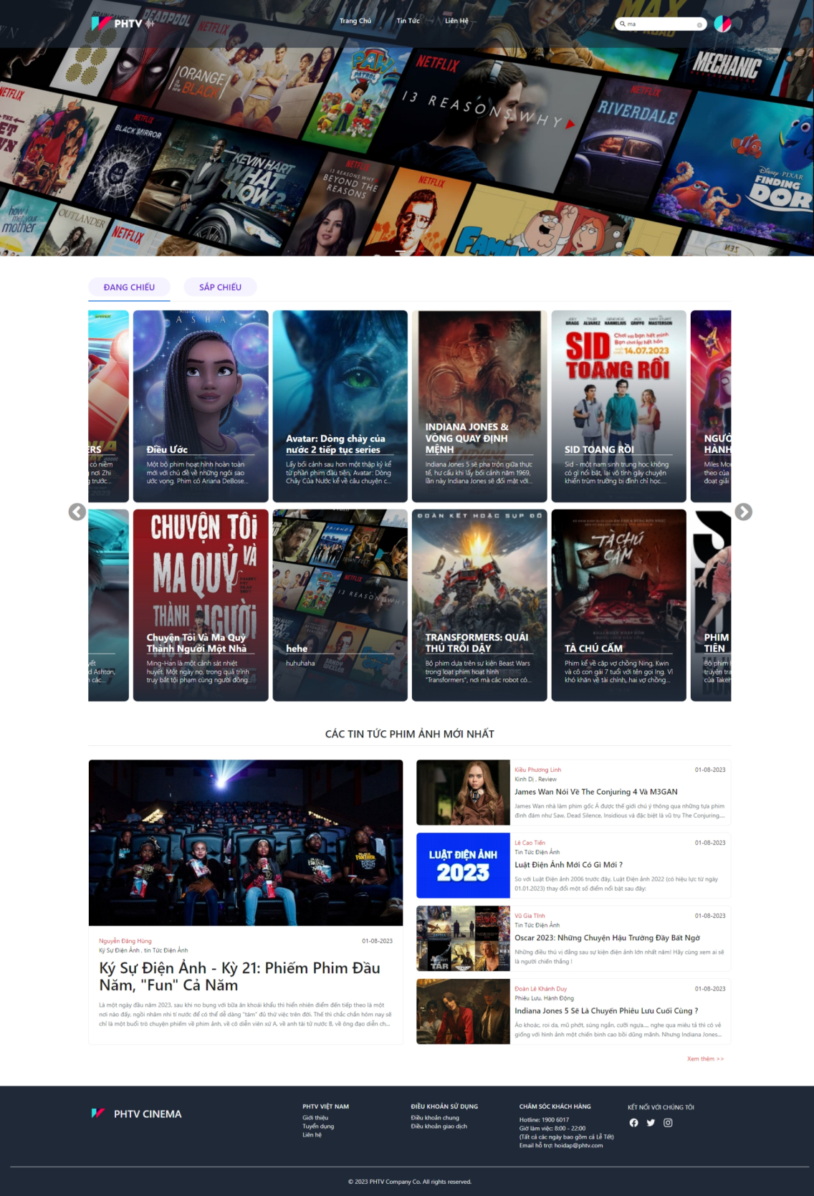

**ADMIN**

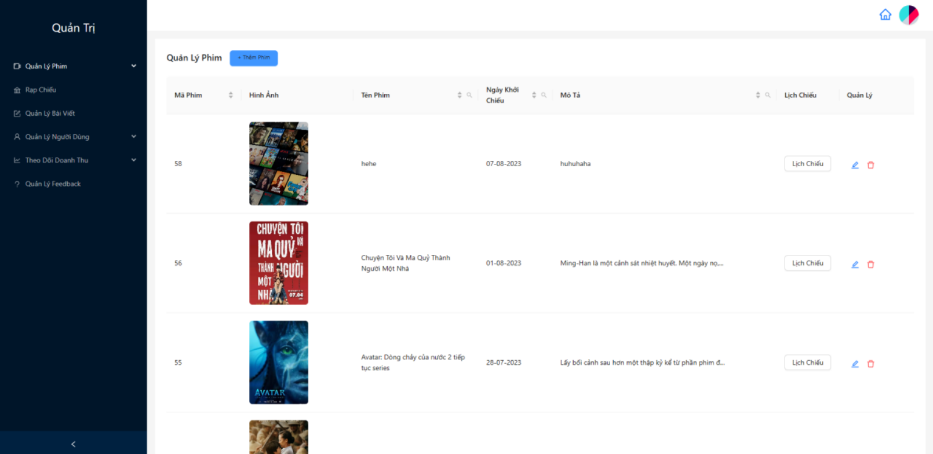

**USER**

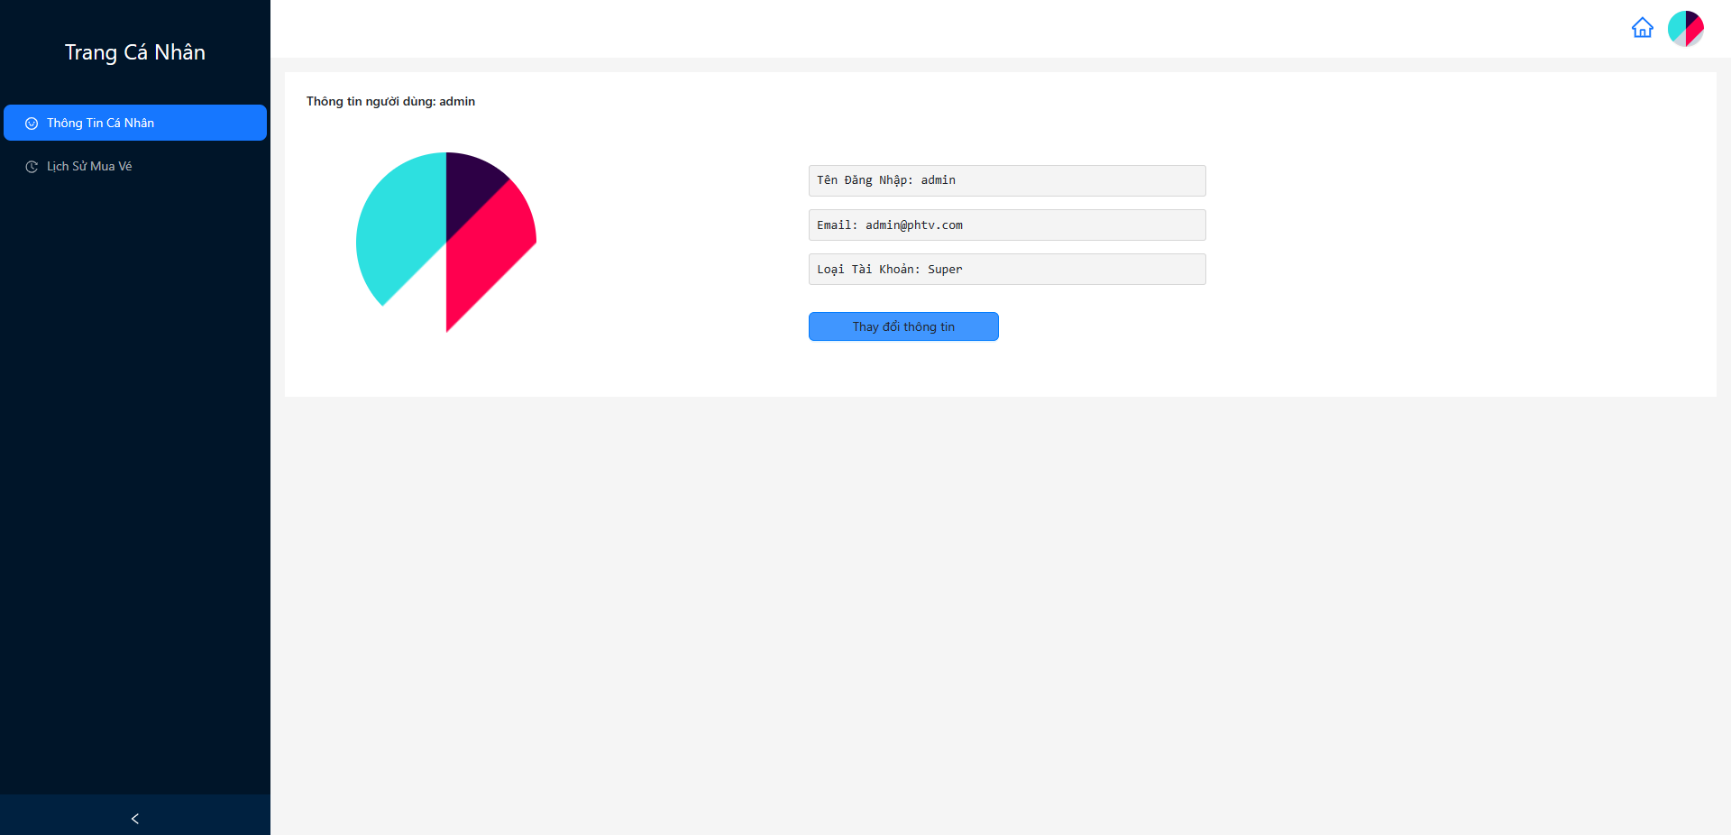

**PRODUCT**

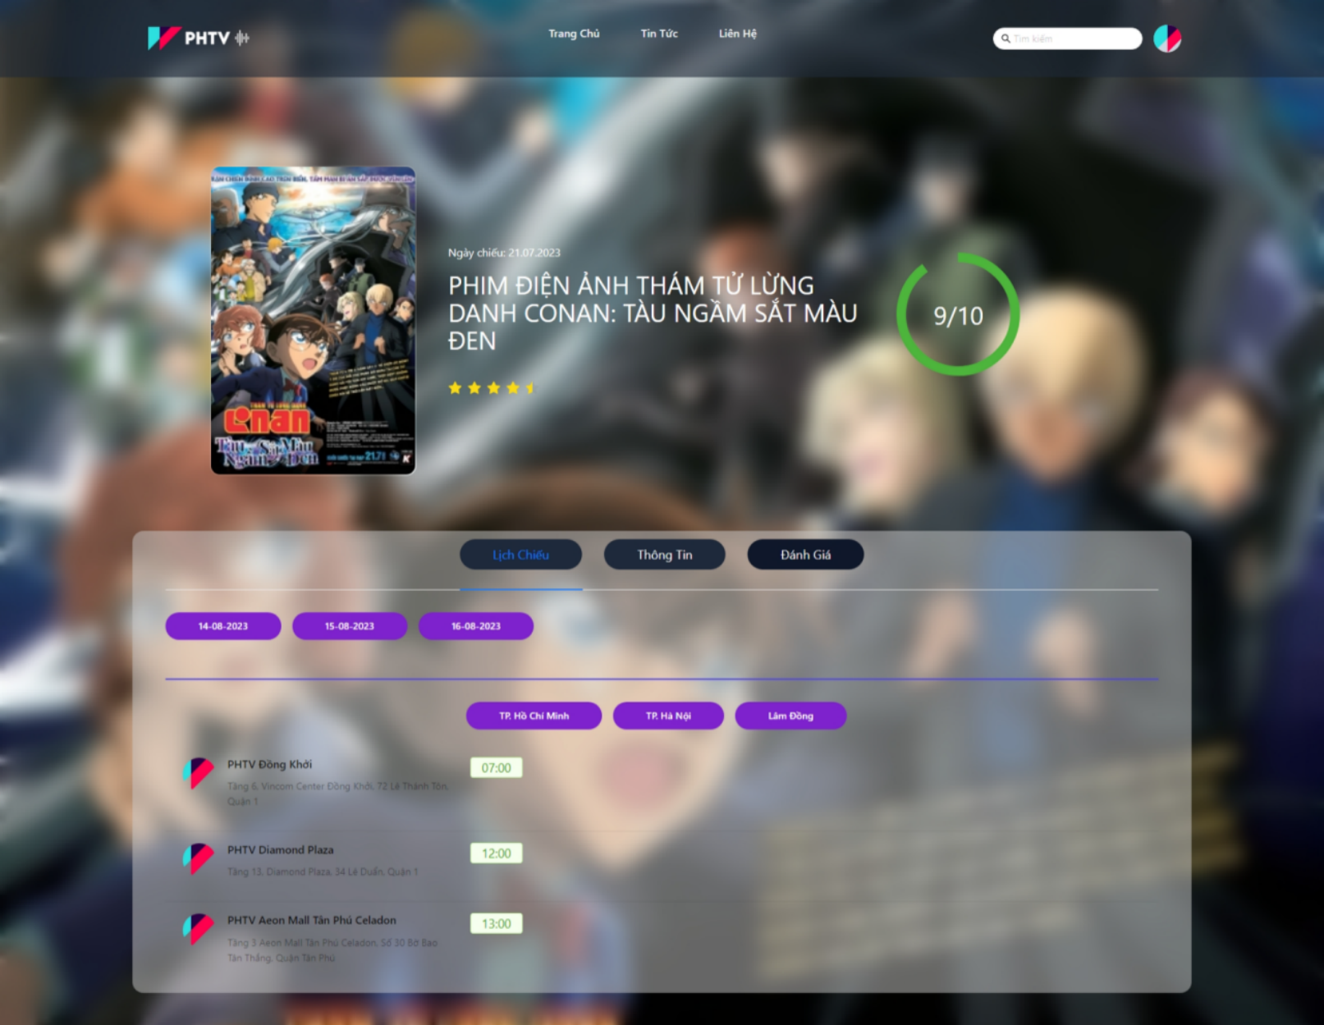

**NEWS**

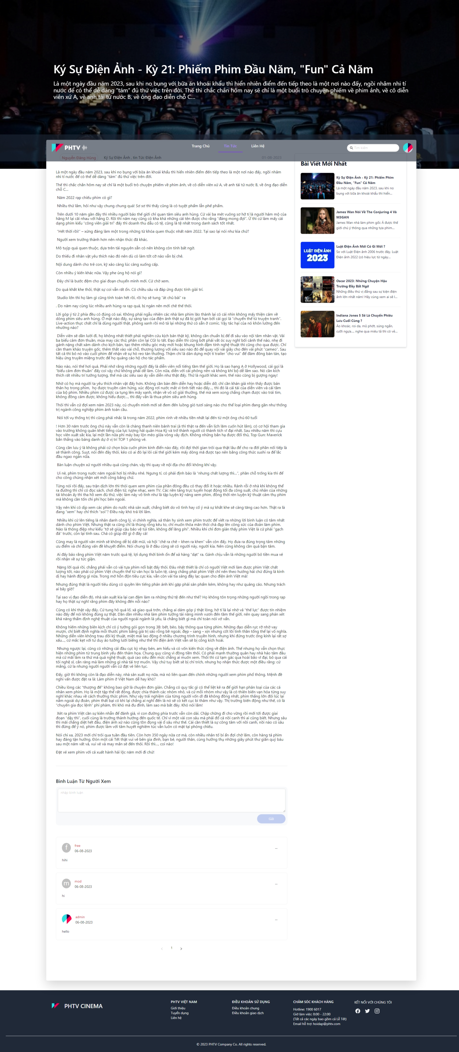



**CONTACT**

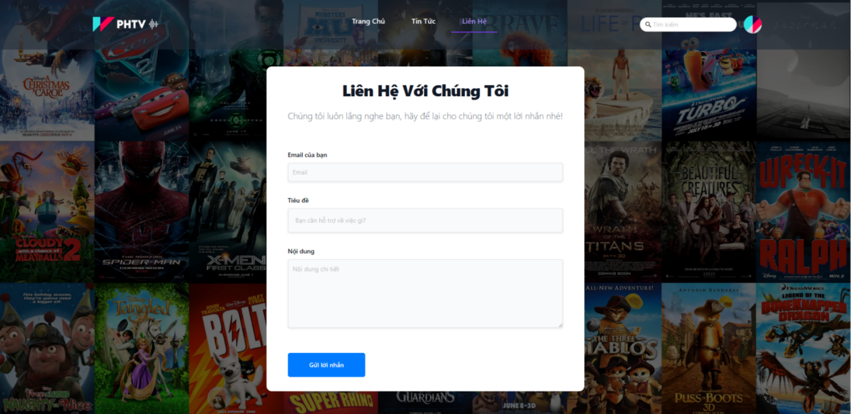

**SEARCH**

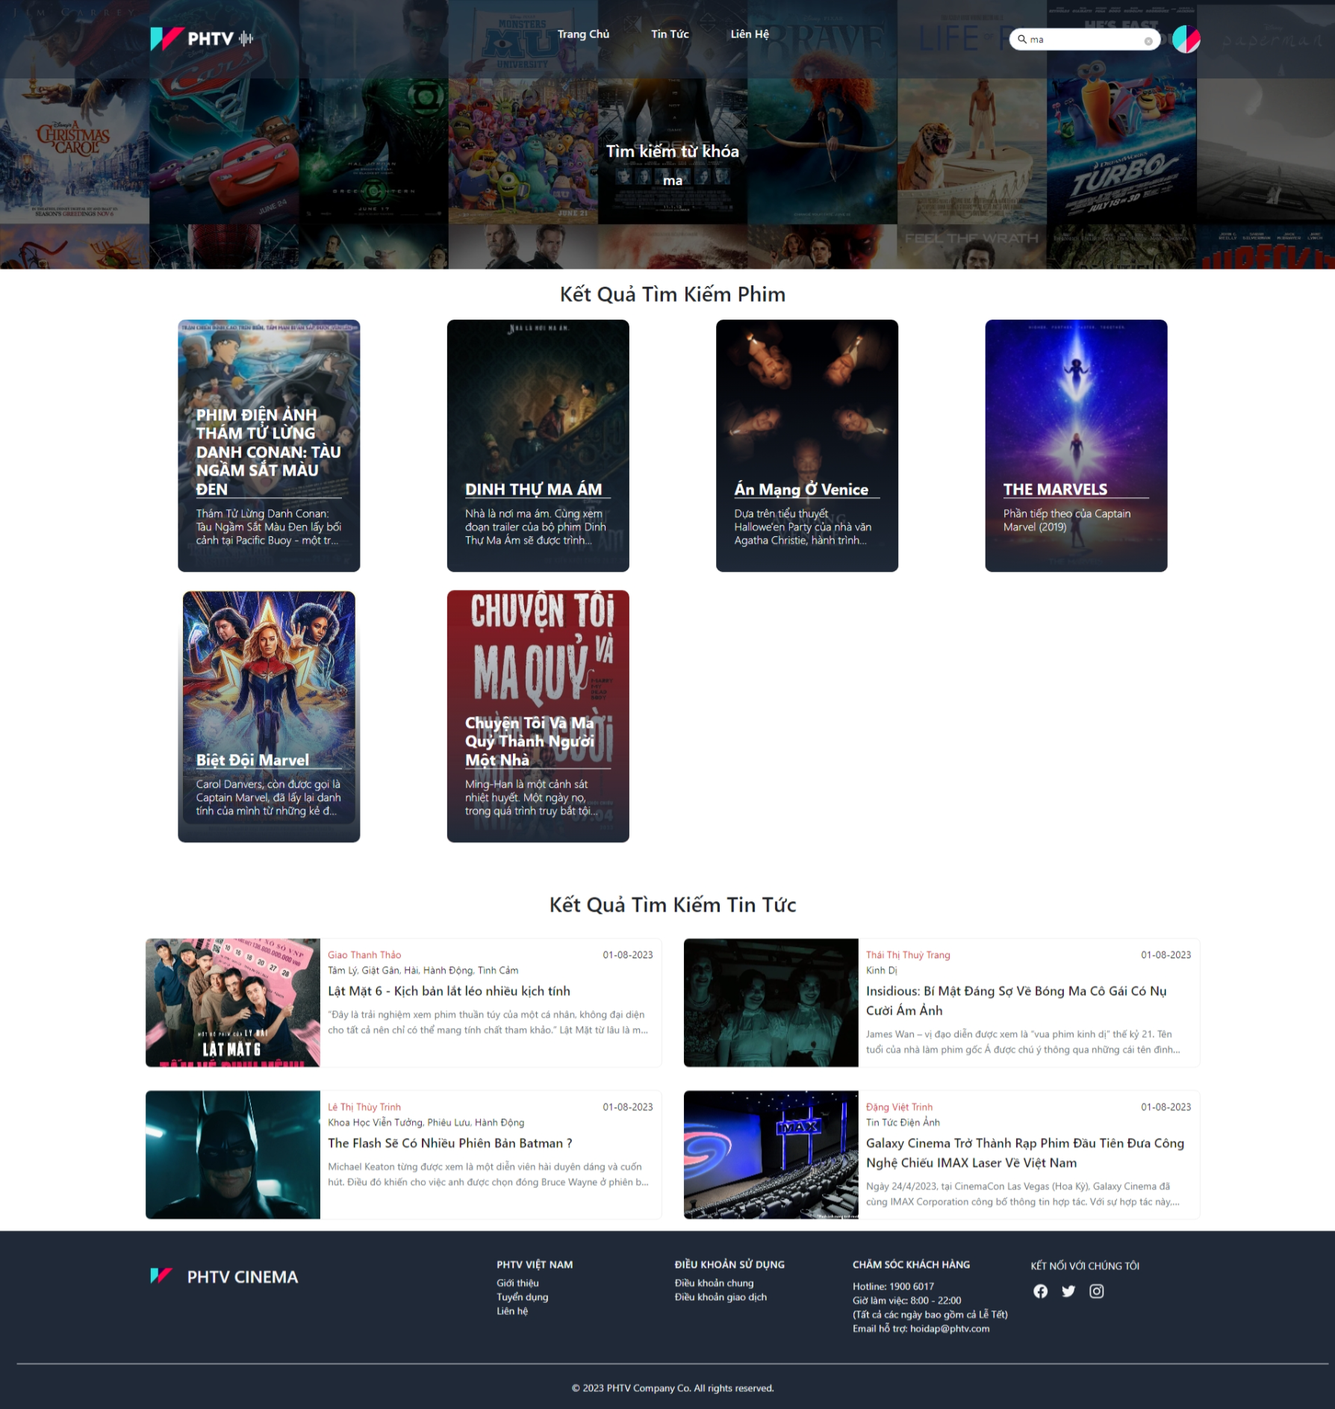

## TASK SHEET REVIEW 3

|  |  |  |  |  |  |  |  |
| --- | --- | --- | --- | --- | --- | --- | --- |
| **Project: Liquor Stores** | | **Project Name** | **Activity Plan Prepared By** | **Date of Preparation of Activity Plan:** | | | |
| **No** | **Task** | **Actual Start Date** | **Actual Days** | **Team member name** | **Status** |
| **1** | **Login/Logout** | **PHTV**  **Cinema** | Hoang | 1/8/2023 | 2 | Phu | Completed |
| **2** | **Register/Reset Password** | 1/8/2023 | 2 | Phu | Completed |
| **3** | **Movie CRUD + Frontend** | 1/8/2023 | 3 | Phu | Completed |
| **4** | **Showtime CRUD + Frontend** | 1/8/2023 | 5 | Phu | Completed |
| **5** | **News CRUD + Frontend** | 1/8/2023 | 1 | Toan | Completed |
| **6** | **News Comment CRUD + Frontend** | 1/8/2023 | 3 | Toan | Completed |
| **7** | **Search** | 1/8/2023 | 2 | Toan | Completed |
| **8** | **Movie Review CRUD** | 1/8/2023 | 3 | Viet | Completed |
| **9** | **Contact CRUD** | 1/8/2023 | 2 | Viet |  |
| **10** | **User CRUD** | 1/8/2023 | 2 | Hoang | Completed |
| **11** | **User Authen** | 1/8/2023 | 2 | Hoang | Completed |
| **12** | **User Authorize** | 1/8/2023 | 2 | Hoang | Completed |
| **13** | **Profile/Avatar Update** |  |  | 1/8/2023 | 1 | Hoang | Completed |
| **14** | **Theatre CRUD** |  |  | 1/8/2023 | 2 | Hoang | Completed |
| **15** | **Carousel CRUD** |  |  | 1/8/2023 | 2 | Hoang | Completed |
| **16** | **Seats Selecting Design** |  |  | 1/8/2023 | 2 | Hoang | Completed |
| **17** | **Place Order** |  |  | 1/8/2023 | 2 | Hoang | Completed |
| **18** | **Payment** |  |  | 1/8/2023 | 1 | Hoang | Completed |
| **19** | **Order History** |  |  | 1/8/2023 | 1 | Hoang | Completed |
| **20** | **Revenue Statistics + Chart** |  |  | 1/8/2023 | 2 | Hoang | Completed |
| **21** | **UI/UX testing** |  |  | 1/8/2023 | 15 | Hoang | Completed |
| **22** | **Database Designing** |  |  | 1/8/2023 | 10 | Hoang | Completed |

**Date: 01 August 2023**

|  |  |
| --- | --- |
| **Signature of Instructor:**  **Mrs. Le Mong Thuy** | **Signature of Team Leader:**  **Pham Huy Hoang** |